Exercise 4: Arrange-Act-Assert (AAA) Pattern, Test Fixtures, Setup and Teardown Methods in JUnit
Implementation:

Calculator.java:
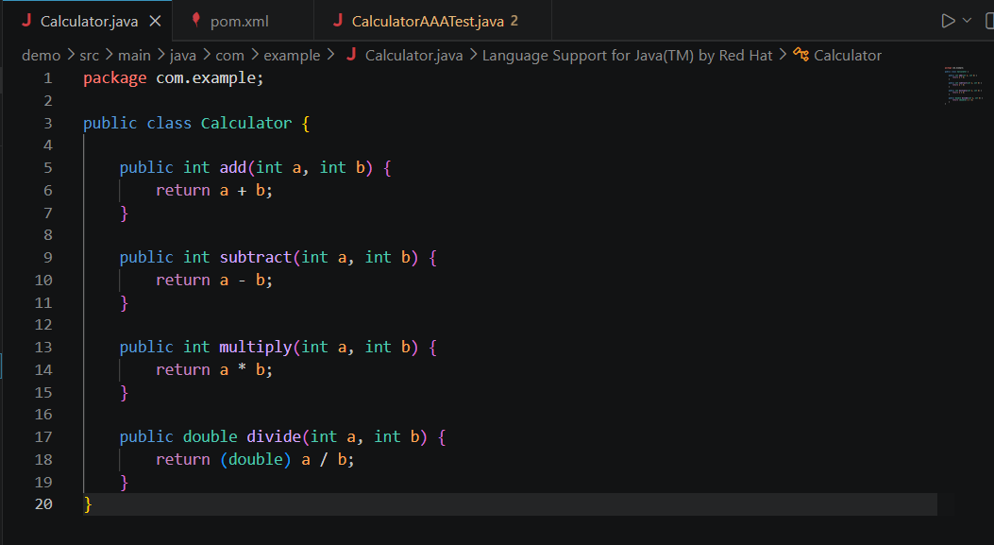
CalculatorAAATest.java: 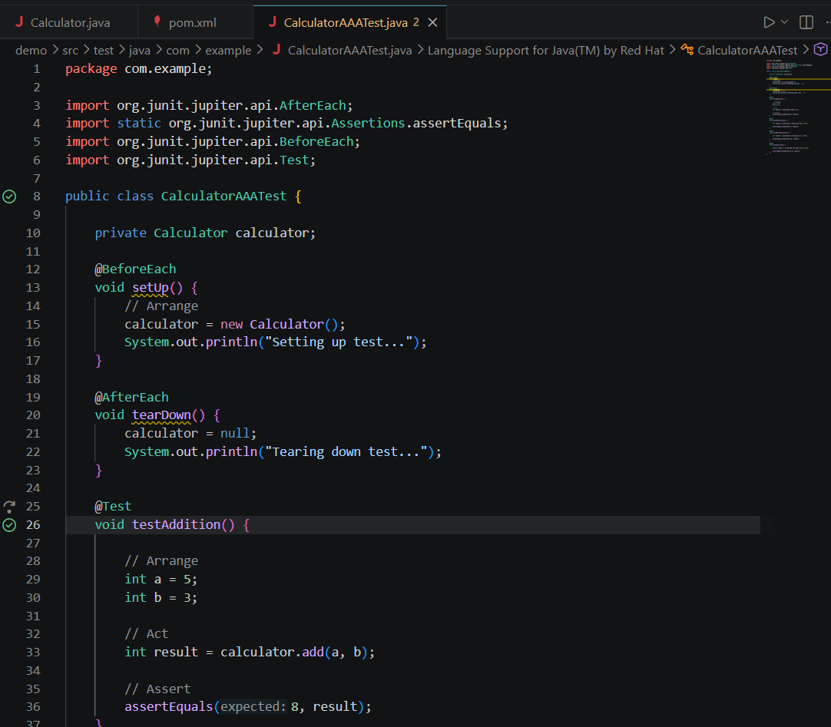

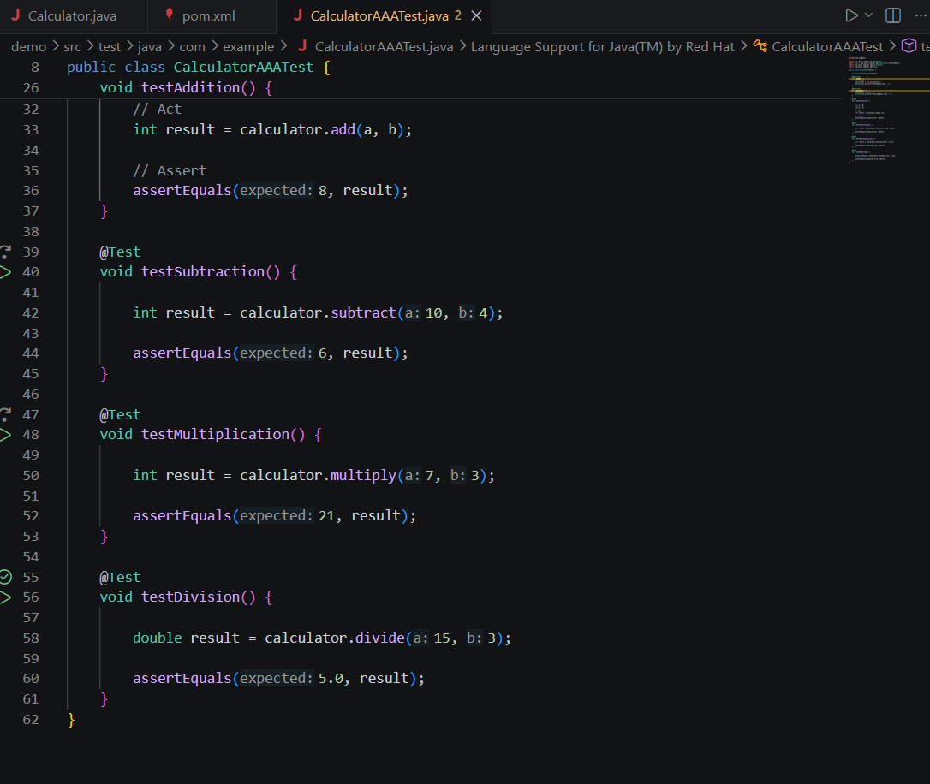

Output:
